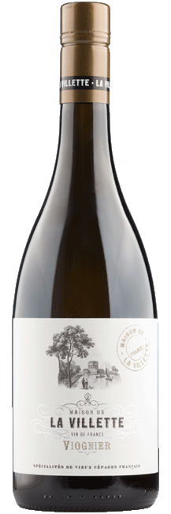

La Villette Viognier VdF
General Information
This wine consists of 100% Viognier grapes from the Herault part in the south of the Minervois, a warm wine region. Combined with the fresh breeze blowing through the vineyard, the wine still has plenty of freshness. The Viognier grape is known for its bouquet of soft fruit and flowers, low acidity and power. The wine is aged for several months in vats on its lees.
Tasting Notes
This Viognier is an aromatic wine with many distinctive fruit tones, such as apricots and peaches. The palate shows a combination of floral notes of acacia flowers, lilies and lavender and hints of fresh bananas.
Food Pairing
Delicious in combination with hearty fish, seafood, creamy pastas and spicy curries.

Producer
La Villette
The purpose of La Villette is to make a wine with the authentically French appearance for wine drinkers all over the world. Besides they want to make a abundant wine in an attractive bottle with a romantic French look, that also represents the quality of the wine.

Product details
  Product Number | 1789/24
  Country | France
  Area | South France
  Subregion | Pays d'Oc
  Color | White
  Alcohol | 13
  Residual Sugar | 0
  Acidity | 0
  Volume | 0.75
  Offline product in
  Distilled | No
  Allergens Egg | No
  Allergens Milk | No
  Allergens Sulphites | Yes
  Allergens Gluten | No
  Biological | No
  Vegan Friendly | No
  Closure type | Screwcap
  Case Quantity | 6
  GTIN code bottle | 3525490025304
  GTIN code case | 3525492025302

