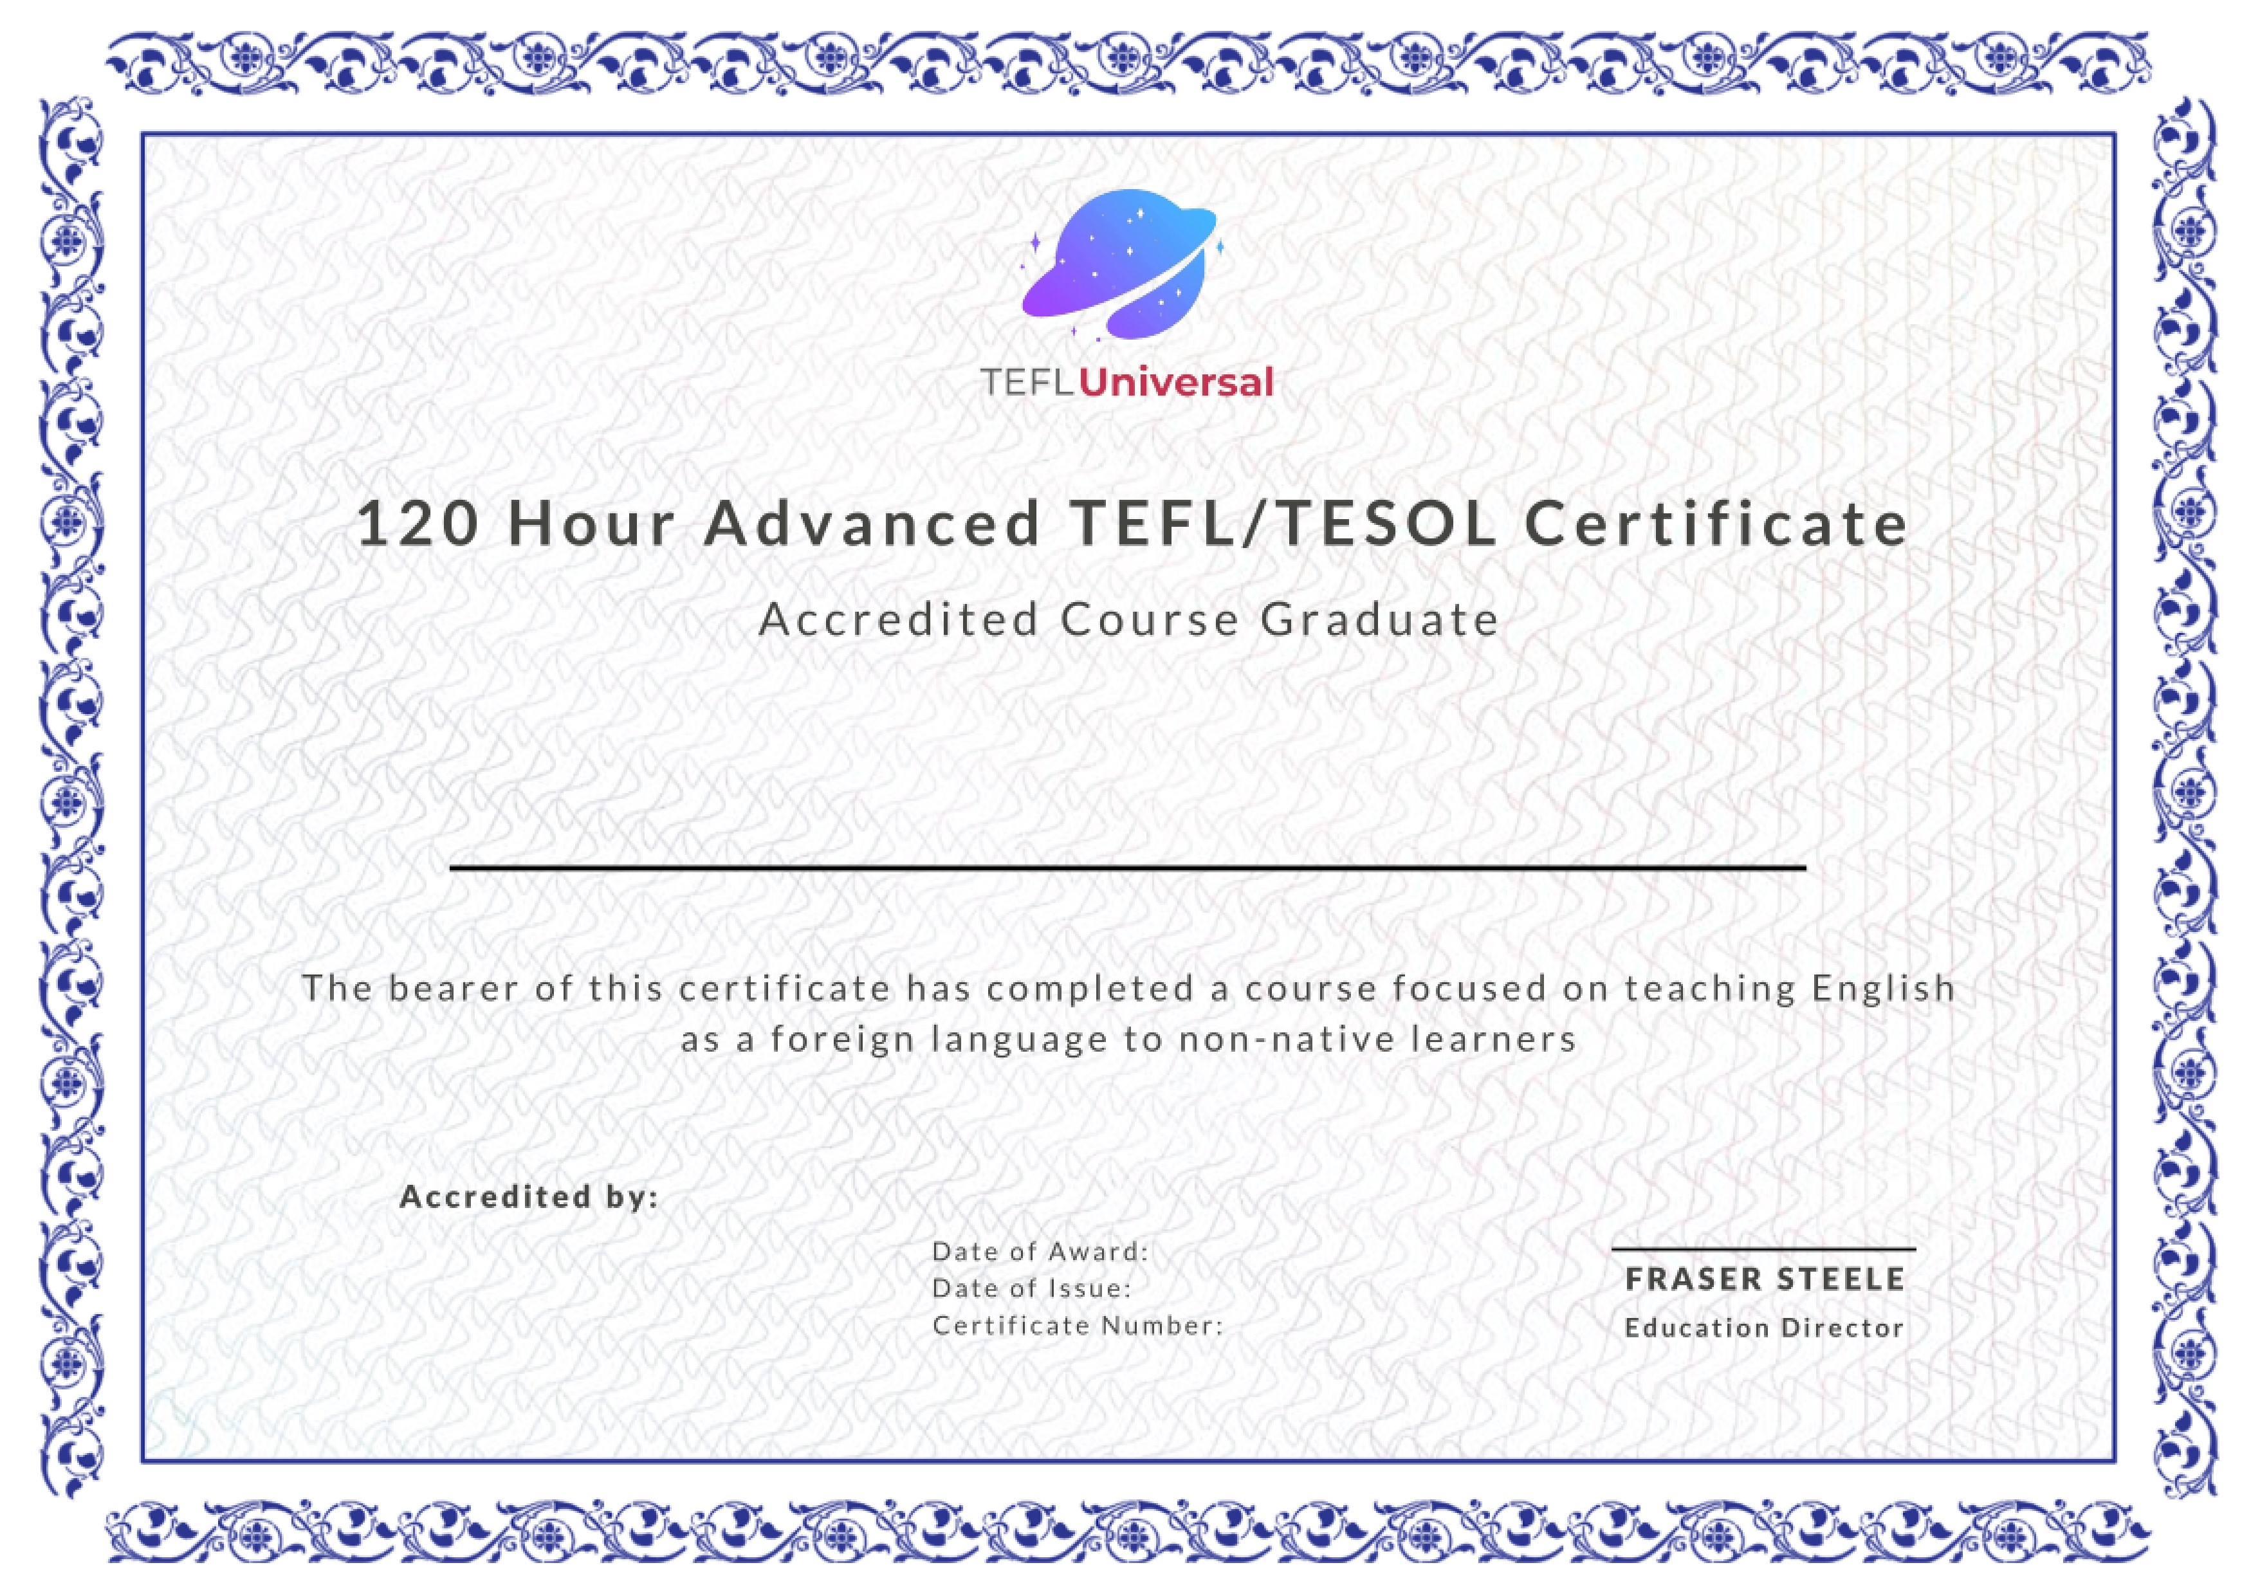
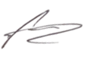

Alexandra King
48258
12/07/2024
12/07/2024

