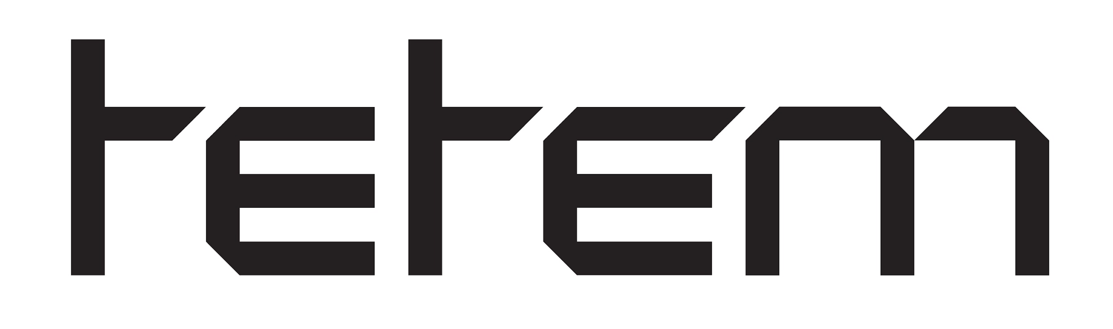

Bring Your Own Beamer: "Game rules"

Important and useful information for BYOB participants, please read this before applying:

Dates and a few house rules:
- Open to the public: Tuesday October 13, 2026 from 19:00-23:00 (7-11 pm)
- Entrance for the public: 7 euro (visitors will receive 7 tokens in exchange and vote on their favourite creation(s) at the BYOB event).
- Building up by participants: Tuesday October 13, 2026 from 15:00-18:30 (please start early so that you have plenty of time for preparation!)
- Breaking down by participants: Tuesday October 13, 2026 from 23:00-23:30
- Don’t forget to hand in your tokens before you leave! At 23:00 the participants can give their received tokens to Adedapo.(1 token = 1 euro) He will let every participant know via email the amount of money they made. Participants can invoice Tetem for the amount. If you don’t work as a freelancer, pay out can be done through IB47-form.
- Location: Tetem, Stroinksbleekweg 16, 7523 ZL Enschede, www.tetem.nl

IMPORTANT NOTE:
Tetem is located in the same building in which people live as well. We have promised our neighbours to keep the noise down after 22:00. This way we can host the BYOB into the late hours without disturbing the neighbours. We kindly ask you to help us with a few practical matters:
- After 22:00 drinks are not allowed outside. If you go outside please consider and respect our neighbours living upstairs by keeping the sound level down.
- After 23:00 we kindly ask everybody not to hang around outside. When breaking down please talk quietly when walking to your car or taking your bike.
- Parking in front of Tetem is not allowed. Though you can park the cars on the streetside at Stroinksbleekweg for free, it’s right on the other side of the building.

Practical information:
- Participation for artists is free
- Your work may consist of anything as long as a projection is involved: artworks, VJ sets, kinect installations, photo series, videos, games, battles, interactive installations, mapping, all of which can add to the mix of image and sound
- Bring your own materials: beamers, media players, other technical equipment, cables, extension cords, basically everything you need for your participation, so PLUG & PLAY.
- Tetem will provide rectangular tables and benches, round cocktail tables and chairs which you can use to put your work/equipment on.
- The ceilings are more than 4,50 meters high and we won’t be able to hang anything from the ceiling. We have seen in the previous editions that there are still plenty of possibilities, just keep in mind that you will be projecting from the ground. If you need extra tables or special things, you can bring it with you.
- Sound is allowed, but not too loud. The sound level should be reasonable because there are people living right above the art spaces.
- Any surface in Tetem’s exhibition space may be used for your projections. However, any use of tape on the walls, or using nails or screws in walls is prohibited, there will be no exceptions.
- Each artist can use a floorspace of 2,5 meters by 2,5 meters. Do you need more space? Fill in how much space you need, under ‘special needs’ in the registration form. We will look at the possibilities together.
- Tetem is not responsible for personal belongings and materials. There are a few lockers available, and you can put your jacket in the unsupervised wardrobe.
- Your space will be assigned to you beforehand, based on your application. The space where you have a spot will be send to the participating artists at least a week before BYOB starts.

Tetem will take care of:
- Empty spaces on floors, walls, ceilings, etc. for the projections
- Free Wi-fi; login and username are: TETEMGast
- Free bar / drinks for participants and visitors
- Promotion of the event

Please note that Tetem does not have regular tables, we do have the following which you can use:
- Large rectangular picknick tables and -benches
- Chairs
- Round cocktail tables (statafels)

Evaluation
Tetem wants to continue developing Bring Your Own Beamer in a way that the impact and meaning of the event can grow. For that reason, we would like to ask every participating artist to fill out an impact-measurement form at the end of BYOB. The forms are handed out by Adedapo. Thank you in advance.

Spread the word, BYOB is once again in Tetem!
Feel free to invite friends to either visit or apply as a participant, the more people, the more fun and the more tokens to vote with! You can find the event on social media and our website.
Instagram @tetemcommunity | Mastodon @tetemkunst

