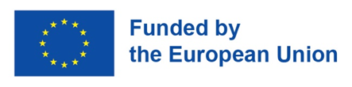


16.02.2023
EU4Culture launches a call for mobility grants for Artists and Cultural Professionals
EU-funded project EU4Culture announces its 3rd call for mobility grants to support Artists and Cultural Professionals from the Eastern Partnership countries: Armenia, Azerbaijan, Belarus, Georgia, Republic of Moldova and Ukraine. This call has a special focus on supporting applicants from non-capital cities.
The EU4Culture Mobility grants are open for internships, study visits, conferences, professional development, and other activities that foster knowledge exchange and intercultural dialogue.
Artists or Cultural Professionals from all cultural sectors over the age of 18, who are citizens or legal residents of these countries are eligible to apply. The call gives a special opportunity to applicants who reside in non-capital cities by allocating half of the call budget specifically for them (This is not applicable to Belarusian and Ukrainian grantees).
The call supports four types of mobilities:
- Short-term mobilities (5-10 calendar days) – up to €1,500
- Medium-term mobilities (up to 5 weeks) - up to €3,500
- Long-term mobilities (up to 12 weeks) - up to €5,000
- Virtual Mobilities (online participation) - up to €1,000
Mobility projects can be implemented between 1 June 2023 – 31 May 2024 in the member states of the European Union, EU partner countries and other European countries.
To apply for the EU4Culture Mobility grants, applicants must submit an action plan and budget for their proposed international mobility through the Goethe Application Portal (GAP).
The deadline for the open call is 27 March 2023, at 15:00 (Central European Time).
On February 23 at 13:00, an information session about the mobility grants will be held on the ZOOM platform. Applicants must pre-register to attend the meeting.
The EU4Culture mobility scheme aims to promote intercultural dialogue and knowledge exchange among Artists and Cultural Professionals in the Eastern Partnership countries. During the first two grant calls, the project supported the mobility projects of 155 individuals. Two more calls will be announced until 2024. EU4Culture is implemented by Goethe-Institut (Lead), Czech Centers, Danish Cultural Institute, Institut Français de Géorgie.
For detailed information about the call, please see the Mobility Call Guidelines.
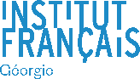

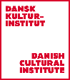

Rusudan Ebralidze, EU4Culture Network and Mobility Manager
Rusudan.Ebralidze@goethe.de

