FOR IMMEDIATE RELEASE:
May 15, 2024
Contact: Michelle Tabnick, 646-765-4773, michelle@michelletabnickpr.com

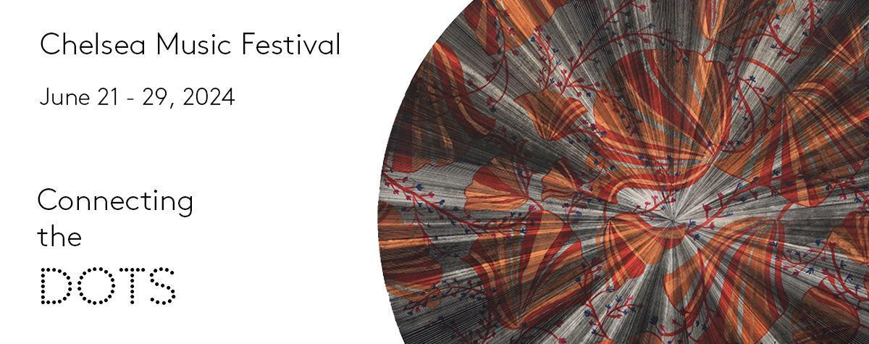
a “gem of a series” - The New York Times
“... impressive addition to New York's cultural ecosystem” - Time Out New York
New York, May 15, 2024— Chelsea Music Festival celebrates its 15th season with nine evenings of concerts, conversation, and tastings with musicians, visual artists, chefs from June 21-29, 2024 — festival tickets are on sale now! This summer Festival, led by Artistic Directors Melinda Lee Masur and Ken-David Masur presents “Connecting the Dots,” which traces how music and art allow us to touch what seems intangible, repair what seems broken, and reimagine our interconnectedness with one another. The Festival will focus on the restorative powers of the arts as we examine ways that music and art both calm and reinvigorate the brain and nervous system. We will also explore together various neurological challenges and changes we can encounter in ourselves and our loved ones. Tickets range from $70-$85. For more information and ticketing, visit https://www.chelseamusicfestival.org/2024/connectingthedots.
Festival concerts will explore these themes with World & US Premieres by Jacob Beranek (Charles Ives scholarship recipient), 2024 Composer-in-Residence Ania Vu (Tanglewood Festival of Contemporary Music), Tebogo Monnakgotla (Tanglewood Festival of Contemporary Music), Nicky Sohn (“Cool 100” by Houston CityBook Magazine), and Grammy award-winning Augusta Read Thomas. Ensembles featured include WindSync (#2 on 2022 Billboard Traditional Classical chart), string quartets Aizuri Quartet (Grammy nominated) and the Harlem Quartet, and The Lee Trio. Featured musicians include acclaimed trumpet player Caleb Hudson (former Canadian Brass), soprano Marisa Karchin, violinist Max Tan, and pianists Robert Fleitz and Andrea Lam. Works by Poulenc (125th), Smetana (200th), Fauré (100th anniversary of his death), Dvořák (120th anniversary of his death), Robert Schumann, Fanny Mendelssohn Hensel, John Williams, Jessie Montgomery, and Caroline Shaw will also be performed. The 15th season’s jazz roster includes multi-Grammy award-winning bassist John Patitucci and Juno award-winning pianist Renee Rosnes, 2021 Guggenheim Fellow Helen Sung’s Quartet, the Adam Birnbaum Trio playing from their critically-acclaimed Preludes album (Chelsea Music Festival Records), and Rogerio Boccato’s Cardume Trio.
A solo art exhibit at High Line Nine will feature 2024 Visual Artist-in-Residence Kelly S. Williams. 2024 Culinary Artist-in-Residence Rachel Snyder will be featured at multiple concert receptions with collaborative creations.
2024 CHELSEA MUSIC FESTIVAL LINE-UP
- Connecting the Dots— 15th Season Opening Night
Friday, June 21 at 7pm at Genesis House, 40A 10th Ave, NYC
  - World Premiere of A Night at Birdland by composer Nicky Sohn performed by WindSync
  - Featuring Aizuri Quartet, pianist Andrea Lam, violinist Max Tan
  - Chamber works by John Williams & Tebogo Monnakgotla
  - Performance of Dancing Stars by Augusta Read Thomas with conductor Ken-David Masur
- My Super Awesome Brain | Family Event
Saturday, June 22 at 10:30am at Pier 57, 25 11th Avenue, NYC
  - 10:30am - Family Event featuring WindSync
- Jazz Doubleheader | Birnbaum & the Bach Preludes and Cardume Trio
Saturday, June 22 at 7pm at Genesis House, 40A 10th Ave, NYC
  - 7pm - Preludes Album (Chelsea Music Festival Records label) featuring pianist Adam Birnbaum, percussionist Keita Ogawa (Snarky Puppy), bassist Matt Clohesy (Darcy James Argue’s Secret Society) based on 12 preludes from Bach’s Well-Tempered Clavier
  - 8:45pm - Late Night with Cardume Trio featuring jazz percussionists Rogério Boccato (Orquestra Jazz Sinfônica do Estado de São Paulo), Keita Ogawa, and Brazilian bassist Cleber Almeida
- Festa Junina
Sunday, June 23 at 7pm at Pier 57, 25 11th Avenue, NYC
  - Traditional Brazilian Forró music to celebrate summer featuring percussionists Rogério Boccato and Cleber Almeida, accordionist Vitor Goncalves, and vocalist Anne Boccato
- Patitucci & Friends — Jazz, Song & Chamber Music
Monday, June 24 at 7pm at High Line Nine, 507 W. 27th Street, NYC
  - Jazz bassist John Patitucci and pianist Renee Rosnes
  - Austrian duo baritone Daniel Gutmann (prize winner at Elīna Garanča’s ZukunftsStimmen) & pianist Maximilian Kromer (International Brahms Competition winner)
  - Featuring pianist Robert Fleitz (1st Prize in 2022 John Cage Award)
  - Reception curated by Chef Rachel Snyder
- Midsummer Night Magic— Visions & Stories
Tuesday, June 25 at 7pm at Czech Center, 321 E. 73rd Street, NYC
  - Festival Pre-Concert Talk (6pm) with Dr. Carlos Diaz Salazar (Zuckerman Mind Brain Institute at Columbia University)
  - Selections from The Lee Trio album “Midsummer Night Magic” (Chelsea Music Festival Records label releasing June 2024)
    - Fern Flowers by Uljas Pulkkis
    - Five Trios by Edmund Finnis
    - Piano Trio No. 2 in F Major, Op. 80 by Robert Schumann
    - Fantasiestücke, Op. 88 by Robert Schumann
  - Austrian duo baritone Daniel Gutmann and pianist Maximilian Kromer performing Liederkreis Op. 24 by Robert Schumann
  - Pianist Robert Fleitz performing Märchentänze (“Dances from Fairytale”) - III. A Skylark by Thomas Ades
  - Performance of the Dumky Piano Trio No. 4 in E minor, Op. 90, B. 166 by Antonín Dvořák (120th anniversary of his death)
- Completed Resonances— Vu, Beranek, Fauré & Smetana
Wednesday, June 26 at 7pm at Czech Center, 321 E. 73rd Street, NYC
  - World Premiere commissioned by the Festival by Czech composer Jacob Beranek
  - Music by Ania Vu featuring soprano Marisa Karchin, pianist Robert Fleitz
  - Piano Trio in G Minor by Bedřich Smetana (200th anniversary) performed by pianist Andrea Lam, violinist Max Tan, and cellist Angela Lee
  - Piano Quartet No. 2 in G minor by Gabriel Fauré (100th anniversary of his death)
- Closing Reception | 2024 Art Exhibition - Kelly S. Williams
Thursday, June 27 at 7pm at High Line Nine Gallery 8, 507 W. 27th Street, NYC
  - Closing Reception for Kelly S. Williams, 2024 Visual Artist-in-Residence
  - Art Exhibition open June 6-29 at High Line Nine
  - Featuring Harlem Quartet performing Jessie Montgomery and Dizzy Gillespie
- Reimagined Gems— Vignettes Across Time
Friday, June 28 at 7pm at St. Paul’s German Church, 315 W. 22nd Street, NYC
  - Festival Pre-Concert Talk (6pm) with Dr. Jessica Phillips-Silver (Growing Brains)
  - Featuring Harlem Quartet performing Caroline Shaw and Fanny Mendelssohn Hensel
  - World Premiere by Ania Vu featuring soprano Marisa Karchin
  - Pieces from trumpet player Caleb Hudson’s 2024 album, Nothing Less, including Corelli arrangements
  - Reception curated by Chef Rachel Snyder
- Superhero Brain | Family Event
Saturday, June 29 at 10:30am at St. Paul’s German Church, 315 W. 22nd Street, NYC
  - 10:30am - Family Event featuring family-friendly, interactive activities led by music neuroscience scholar Dr. Jessica Phillips-Silver (Growing Brains)
- Festival Finale | Jazz Plasticity with Helen Sung
Saturday, June 29 at 7pm at DiMenna Center, 450 W. 37th Street, NYC
  - JazzPlasticity features the Helen Sung Quartet with pianist Helen Sung (2021 Guggenheim Fellow), drummer Kendrick Scott, saxophonist/clarinetist John Ellis, an bassist David Wong; this program was inspired by Helen’s time as jazz artist-in-residence at the Columbia University Zuckerman Mind Brain Institute and in partnership with Arts & Minds.
  - Intermission talk by neuroscientist Dr. Sarah Woolley (Zuckerman Mind Brain Institute at Columbia University)
  - Reception curated by Chef Rachel Snyder
All programming subject to change

Photos of artists are available for download here.
Banner Artwork includes a detail of a painting by Kelly S. Williams

Festival Sponsors & Partners: Arts & Minds, Austrian Cultural Forum New York, Carl Brandt, Inc., Columbia Alumni Association Arts Access, Consulate General of Germany in New York, Fordham University, German International School New York, Harney & Sons, Growing Brains, Honeybrains, Insomnia Cookies, Anna-Maria and Stephen Kellen Foundation, Lower Manhattan Cultural Council, Michael J. Fox Foundation, New School College of Performing Arts, New York State Council of the Art, NYC Department of Cultural Affairs, Polycast Productions, Rachel Snyder Hospitality, Radeberger Gruppe USA, Skylight Arts Productions, Steinway & Sons, Tarisio Fine Instruments & Bows, WBGO, WQXR, Wunderwein, Zuckerman Mind Brain Institute at Columbia University
STAY UPDATED
Web - ChelseaMusicFestival.org | YouTube - ChelseaMusicFestivalNYC
LinkTree - ChelseaMusicFestival | Facebook - Facebook.com/ChelseaMusicFestival
Twitter - @CMF_NYC | Instagram - @CMF_NYC

MOTTO - HEAR | TASTE | SEE

ABOUT THE CHELSEA MUSIC FESTIVAL
Chelsea Music Festival celebrates great music by convening world-leading musicians & artists in the performing, culinary, and visual arts for an international audience. The Festival invites artists, composers, and performers to collaborate in pursuit of new perspectives in artistic expression. Inspired by its Chelsea roots, the Festival reflects the creativity of one of New York City's most dynamic neighborhoods. Programs span musical genres ranging from classical to contemporary to jazz with a special emphasis on Festival commissions by composers whose works are not in the traditional western canon. In addition, the Festival hosts an online library of recordings so music enthusiasts, artists, and students alike can explore unique interpretations of classical, jazz, and contemporary works via high-quality videos of world-class performances.

Since 2010, the Festival has established itself as a critically-acclaimed, accessible and interactive gateway to chamber music in non-traditional concert spaces such as art galleries, public squares, schools, and churches. Programming includes concerts, lectures, exhibitions, family events, and free outreach performances. In 2020, the Festival inaugurated its Online Encores and Online Originals YouTube series; Online Encores presents highlights from Festival archives while Online Originals presents new performances and recordings. We are proud to give emerging voices, particularly those of women and people of color, a stage and are working to build an audience and intimate community to support a new generation of musicians, composers, and artists.

The Chelsea Music Festival Artistic Directors are Melinda Lee Masur and Ken-David Masur.

#

