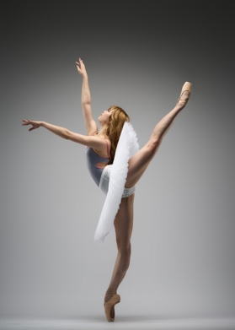

Age:19 Date of birth:March 05,2004 Nationality:Japan Height:166cm Weight:47kg. Language:Japanese,English,German
E-mail:noashoda@gmail.com Tel:+81 09068227168 Address:935 Saho, Ibaraki City,Osaka
Education/Training
2021-2023 John Cranko Schule Graduated Primary Instructors:Tadeusz Matacz, Natalia Gasmaeva, Catarina Mora
2011-2021 Jinushi Kaoru Ecole de Ballet Primary Instructors:Kaoru Jinushi, Eri Murata, Yui Okumura
2007-2011 Angelot Ballet School Primary Instructors:Kayo Isayama
Career
2023-presents Ballet Company West Japan Soloist
Performing Experience
2023 Ballet Company West Japan , Raymonda performed waltz and grand pas classic
2023 With Love from Malakhov 2023 Performed Paquita soloist, Wadaiko, Spain from Nutcracker and Jupiter
2023 Jinushi Kaoru Ballet Company, Coppélia Performed Mazurka and waltz of the hours
2023 John Cranko Schule, Ballet Matinee of the John Cranko School Performed La Nascita di Venere
2023 JohnCranko Schule,Guest performance in Ludwigsburg Performed Salade and La Nascita di Venere
2022 John Cranko Schule,Aktion Weinachten Performed Pas de huit and La nascita di venere(Thalia)
2022 Jinushi Kaoru Ballet Company,Giselle Performed Village girl and Willlis
2022 Jinushi Kaoru Ballet Company,Cinderella Performed Spirit of spring and Waltz
2021 John Cranko Schule,50 Year Gala Performed Kitri’s friend variation and Classical Symphony
2021 John Cranko Schule,Aktion Weinachten Performed Classical Symphony
2021 Jinushi Kaoru Ballet Company,Don Quixote Performed Kitri’s friend
2019 Passion du Ballet a Kyoto,Exhibition Performed Black Swan variation
2019 Jinushi Kaoru Ballet Company,The Little Mermaid Performed Cherry shell,Loveka and Shlphide
2019 Second Stage 15th anniversary concert Performed Black Swan variation
2018 Jinushi Kaoru Ballet Company,Sleeping Beauty Performed Fairy and Spirit of the forest
2018 Ballet Competition in Osaka,Exhibition Performed Harlequinada variation
2016 Passion de Ballet a Kyoto,Exhibition Performed Dulcinea Variation
2015 Jinushi Kaoru Ecole de Ballet,Nutcracker Performed Clara(Masha)
2013 The National Ballet of Japan,Cinderella Performed Page girl

Awards
2020 Youth Grand Prix Japan 2nd place, ensemble
2019 Korea National Classical Ballet Competition 1st place, junior
2018 Passion du Ballet a Kyoto 1st place, junior women
2017 The ballet Competition in Osaka 1st Place, junior
2015 Passion du Ballet a Kyoto 1st place, junior

