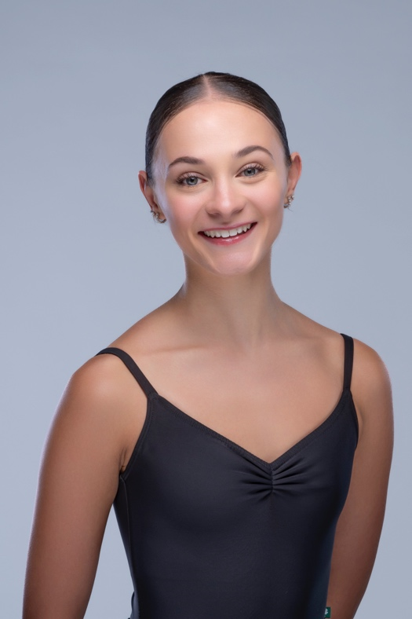
Chelsea Marriott

Personal Details
Date of Birth: 11th November 2004
Age: 19 Years
Address: 12 Blueberry Place, Alfords Point, NSW, 2234, Australia
E-Mail: chelseagrace1104@gmail.com
Phone Number: +1(646)3794604
Height: 172cm (5’7”)
Weight: 52kgs (114lb)
Passports:
- Australian Passport
- UK Passport
- Dutch Residency
- Applicable for US Visa
Training
- Cary Ballet Conservatory Professional Training Program - Advanced Level
2022-Present under Mariaelena Ruiz, Heather Iler, and Matthew Donnell

- Taina Morales Professional Ballet Program – Romania
2020-2022 under Taina Morales and Carlos Valcarcel

- Rogerson Elite Classical Training – Australia
2016-2020
Other Skills
Dance Training in Contemporary, Jazz, Musical Theatre, Hip-Hop, Tap and Acrobatics.
Accomplishments
2023 YAGP Winston-Salem 3rd Place Senior Classical & Top 12 Senior Contemporary
2023 ADC|IBC Finals Top 25 Senior Women
2023 YAGP & ADC|IBC Finalist
2023 ADC|IBC Raleigh 4th Place Senior Classical
2023 Grand Audition Barcelona 2nd Round
2022 YGP Paris 3rd Place Senior Contemporary & Top 12 Senior Classical
2022 Cary Ballet Conservatory Prix Challenge Week & Summer Intensive
2022 Ellison Ballet Summer Intensive
2021 Dutch National Ballet Academy Virtual Summer Intensive
2020 Royal Ballet School Virtual Intensive
2020 Ellison Ballet Virtual Summer Intensive
2020 Princess Grace Academy Winter Intensive
2019 YGP Paris Final Round
2019 Princess Grace Academy Summer Intensive
2019 ABT JKO School Summer Intensive

Roles Performed
2023 “Sugarplum Fairy” Pas De Deux and Solo in Cary Ballet Company’s The Nutcracker
2022 “Arabian Lead” in Cary Ballet Company the Nutcracker
2023 “Swanhilda” in Cary Ballet Company’s full-length production of Coppelia
2022 “Arabian Lead” in Cary Ballet Company’s the Nutcracker
2022 “Snow corps” in Cary Ballet Company’s the Nutcracker
2022 “Marzipan corps” in Cary Ballet Company’s the Nutcracker

2023 Cast as “Stairway to Paradise” Solo and Pas De Deux in “Who Cares” being set by the George Balanchine Trust for Cary Ballet Company (Spring 2024)

